**Constants**



Value cant change and its constant.

We use all capital letters to name constants.

**Order of Operations**

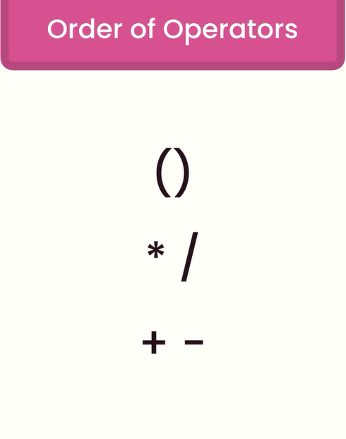

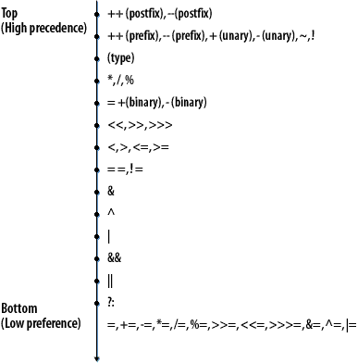

**Casting**

Implicit Casting: automatic casting or conversion, when we have a value that can be converted to a data type that is bigger, casting or conversion happens automatically.



This will happen because we don’t want data loss.

Explicit Casting: can only happen between compatible types.

**The Math Class**

Rounding: Math.round(number)

Ceiling: Math.ceil (number)

floor: Math.floor(number)

Max of 2 values: Math.max(number1, number2)

Min of 2 values: Math.min(number1, number2)

Random value between 0 and 1: Math.random()

Random value between 0 and 100: Math.random()*100

Random value between 0 and 100 rounded: Math.round(Math.random()*100)

Random value between 0 and 100 (integer): (int)Math.round(Math.random()*100)

Random value between 0 and 100 (integer): (int) (Math.random()*100)

**Formatting Numbers**

NumberFormat Class



Its abstract class



This will be:



To format a number into percent:



And result would be 10%